DELEGATION FROM USLGE AND RSG TO VISIT TCOEFS FOR EVALUATION OF PROPOSED SMALL RUMINANT DEVELOPMENT PROJECT

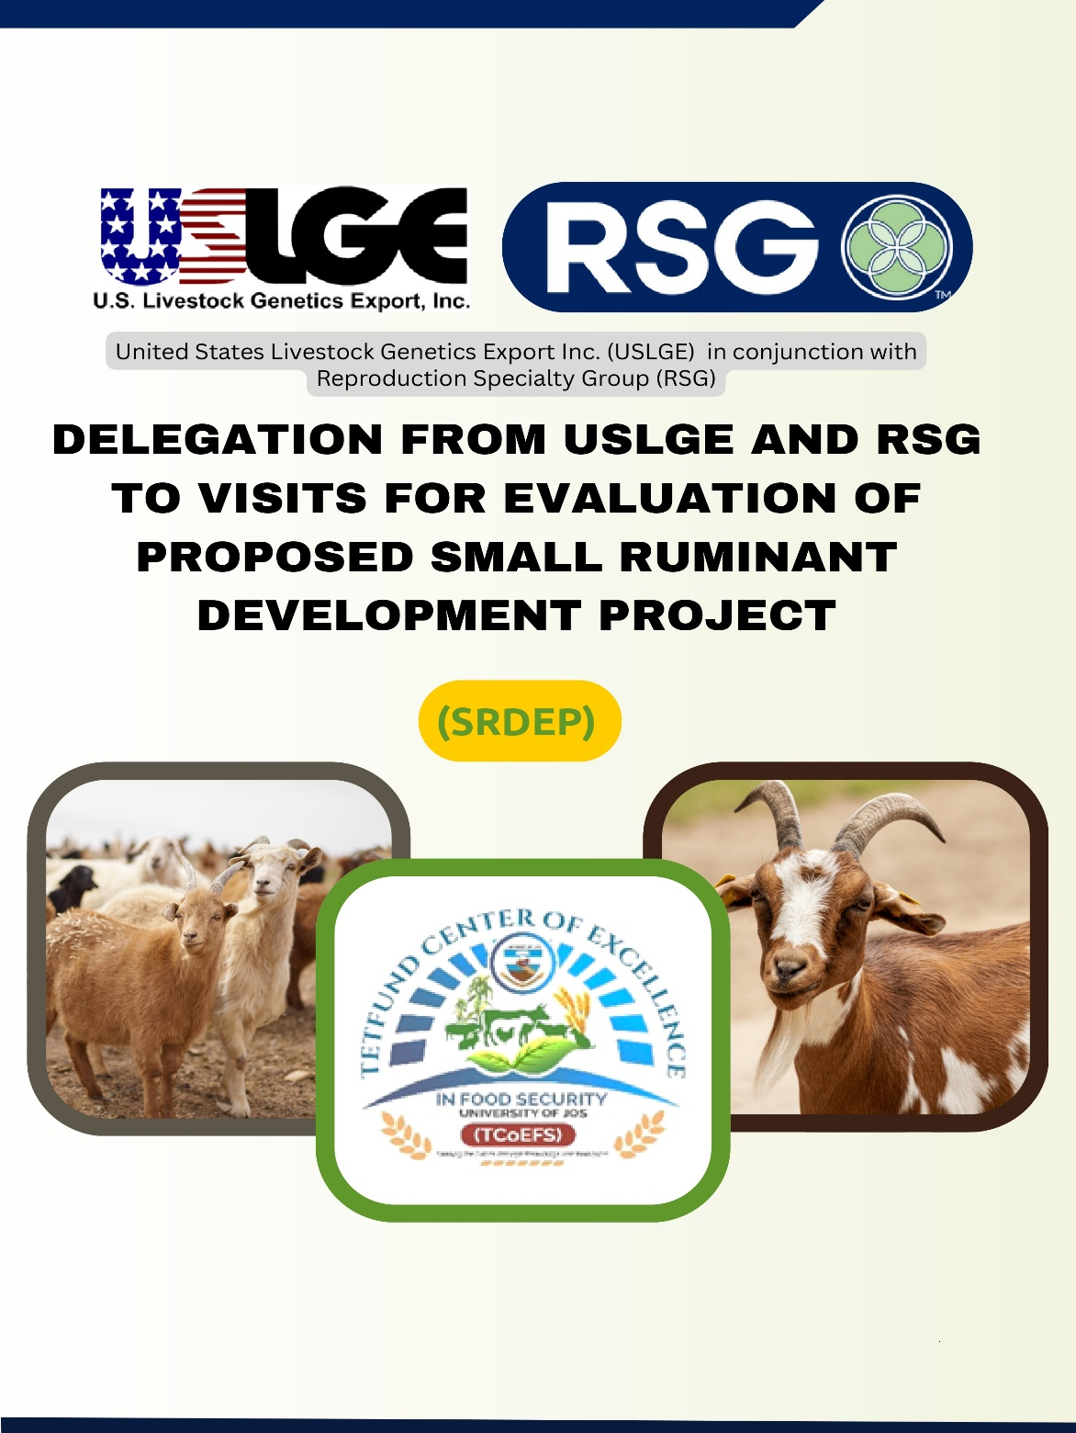
The TETFund Centre of Excellence in Food Security (TCoEFS), University of Jos, will host a high-level delegation from the United States Livestock Genetics Export Inc. (USLGE) and the Reproduction Specialty Group (RSG) for the evaluation of the proposed Small Ruminant Development Enhancement Project (SRDEP).
The delegation, scheduled to visit in October 2025, will include DR. Martin Sieber, President and Chief Executive Officer of USLGE, and DR. Doug Edge, Chief Strategy Officer of RSG. Their visit aims to assess the feasibility, visibility, and institutional preparedness for the potential implementation of the SRDEP in Nigeria.
The Small Ruminant Development Enhancement Project (SRDEP) is a collaborative initiative developed by Dajrhas Health and Agric Development Ltd in partnership with TCoEFS, the Federal Ministry of Livestock Development, State Ministries of Agriculture and Livestock Development (Imo, Gombe, Oyo, Plateau, and Kaduna States), the National Animal Production Research Institute (NAPRI), the National Veterinary Research Institute (NVRI), the Sheep and Goat Farmers Association of Nigeria, Sahel Consulting Agriculture and Nutrition Ltd, the Commercial Dairy Ranchers Association of Nigeria (CODARAN), and the Cochran Fellows.
The project seeks to enhance Nigeria’s small ruminant value chains by improving breeding practices, strengthening animal health systems, expanding feed production, and creating stronger market linkages for smallholder farmers. If approved, the initiative will contribute significantly to national food security and rural livelihoods.
The evaluation visit will include stakeholder meetings, facility inspections, and technical sessions coordinated by TCoEFS. The Centre will highlight its research infrastructure, training capacity, and ongoing programmes aligned with the project’s objectives.
The partnership and evaluation mission were facilitated through Prof. Dauda Bawa, Director of TCoEFS and a Cochran Fellow under the U.S. Department of Agriculture’s Cochran Fellowship Program. His fellowship experience and collaboration with U.S. agricultural development institutions established the professional linkages that made this engagement possible.
According to Prof. Bawa, “the forthcoming visit by Mr. Martin Sieber and Mr. Doug Edge represents a significant opportunity to strengthen international collaboration in livestock development. Through this partnership, we aim to foster innovation, improve smallholder productivity, and contribute to sustainable food security in Nigeria.”

